**How to Manage Post Listing Pages | FASD**

**following the steps below.**

**Post listing pages**

We have some pages on our website where post listings come along with filters. These are three pages:

a) Videos Hub

b) Resources

c) News and Events

# **—Videos Hub**

**We have set separate fields for the three pages. The same fields will be accessible across all three pages, allowing you to edit them in the same way. Therefore, we are providing a review of the Videos Hub page. Let's open the Videos Hub page and check how the sections are being managed and how everything is functioning.**

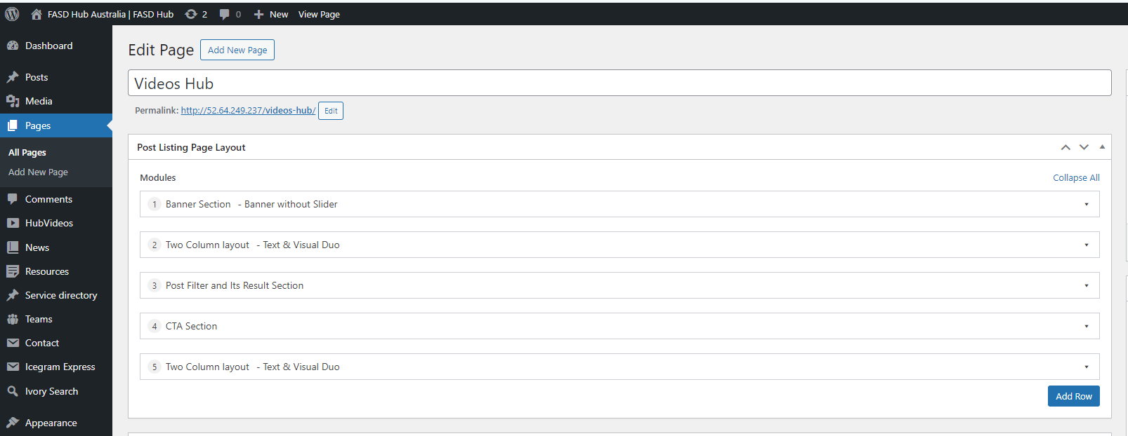

Please take a look; four layout options have been added here, as shown in the screenshot below.

1. Banner Section

2. Post Filter and Its Result Section

3. Two Column layout  
4. CTA Section

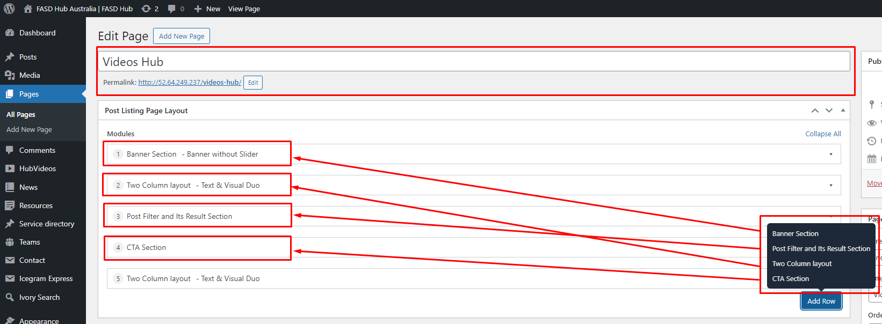

Now, if we want to modify the content of any section, we'll need to click on it to open it. If we want to re-add any section, we'll need to click on the respective layout to add it, as shown in the screenshot below.

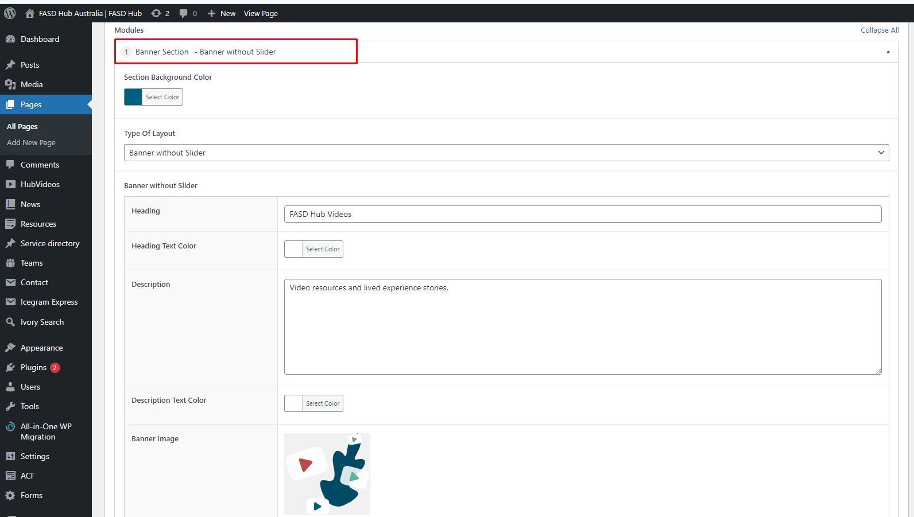

We have described in '**The Complete Guide to Creating Website Sections | FASD'** document how to modify these sections and how to add new sections. You can follow that document to check. However, on these three pages, you will find a layout named **'Post Filter and Its Result Section'** under the field named '**Filter Shortcode**,' Here, you need to put a special code called a **'shortcode'** to show posts with filters. We've already put these shortcodes there. Please don't remove them by accident. If they're deleted, we've listed them below for you to use again.

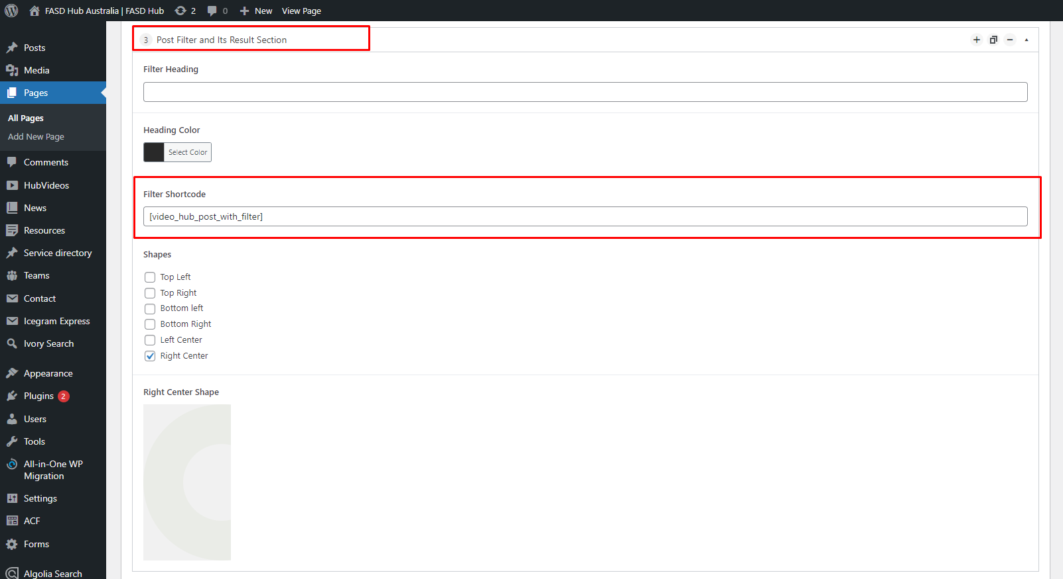

# **—Shortcodes used for the following pages:**

**a) Videos Hub: Posts listing with filters**

**Shortcode = [video_hub_post_with_filter]**

**Preview as shown in the screenshot below.**

**b) Resources: Posts listing with filters**

**Shortcode = [resources_posts_with_filter]**

**Preview as shown in the screenshot below.**



**c) News and Events: Posts listing with filters**

**Shortcode = [news_events_posts]**

**Preview as shown in the screenshot below.**

